Luma – System information

Contents

LIGHTING CONTROL . 3

Overview of Lighting control 3

DIGITEX - Leading / Trailing Edge 3

DIGITEX - Zigbee Communication 4

DIGITEX - Programming NET 4

DIGITEX - compatibility 5

Trailing Edge 5

Leading Edge 6

MVHR boost 7

MVHR Location 7

HEATING CONTROL . 8

Room Thermostat 8

Programming options 9

HAGW programmer 10

Connecting 10

HAGW software 11

Website 11

os.mbed.com 11

Home Page 12

Files 12

Compiling File for HAGW 13

Setting for Gateway 1 13

Setting for Gateway 2 14

Setting for Gateway 3 14

Adjusting Fan Max 15

Adjusting Fan speed medium and high 16

Relay / Actuator reference to Zone 17

Make the file for the HAGW 18

Links 20

# LIGHTING CONTROL .

# Overview of Lighting control

The project was initially installed with DB8 8W Engines and Diablo-MIN-DR-DIM-2IC (Leading edge) and DIGI3 Light switches (Trailing Edge).

The switches (majority) have been changed back to DIGI V2 (leading edge)

# DIGITEX - Leading / Trailing Edge

Majority of apartments have now been installed with DIGI2 (DIGI V2) Leading edge Light switches.

There are a few apartments where DIGI3 (DIGI V3) have been installed to allow trailing edge lighting control.

These apartments are typically large apartments with architectural lighting or where light levels were poor and 13W drivers were installed.

***Q: Can you mix Trailing edge and Leading edge LED source on same switch.***

*A: This depends on driver. Linear drivers are normally large in size and have additional components to allow both types of dimming. Downlights are smaller in size and have strict rules on installation. The light switch must be the same as the downlights.*

***Q: How can you tell the difference***

*A: On the rear of the unit will have label DIGI V2 or DIGI V3*

*A: If you remove the front cover (plastic) and hold down “set” button for 5 seconds, Let go and press again for 5 seconds (if the down button is lit on its own it is DIGI V3 – if not DIGI V2.*

***Q: Buzzing on LED or Switch***

*A: Buzzing is normal on dimmable LED circuits. Although it is more noticeable on Leading edge. Luma has had installation of Shaving sockets that amplified the buzzing. Luma has had incidents of loose connections which will cause the circuit to buzz.*

***Q: can you easily replace the smart light switches (like for like).***

*A: this depends on what part is faulty. The front PCBA has the memory and can be swapped, although it is extremely unusual for the rear part to be faulty as it is the mechanical components (no intelligence)*

*A: When swapping you must remember to NET the switch to the screen (same wireless address) and then pair to any circuits where applicable (i.e. additional 2-way), MVHR and Screen.*

***Q: can you swap the light switch from Leading to Trailing and/or Trailing to Leading edge.***

*A: this is possible, however make sure all light sources on circuit are the same type.*

*A: When swapping you must remember to NET the switch to the screen (same wireless address) and then pair to any circuits where applicable (i.e. additional 2-way), MVHR and Screen.*

***Q: when we swapped the front PCBA the lights are constantly***

*A: the PCBA still has the opposite firmware (trailing / Leading) . Re flash the correct firmware and after 45sec it will revert and normalise the output.*

*A: in rare occasions the switch line output could be blown (excess or non-dimming load), replace product.*

# DIGITEX - Zigbee Communication

The light switches have wireless Zigbee technology that allow them to communicate for 2-way switching and Screen / Mobile APP control.

There are several stages of programming.

# DIGITEX - Programming NET

Video D01: <http://downloads.orcomm.co.uk/#Downloads%2FVideos>

# DIGITEX – Pairing to Screen

Video D03: <http://downloads.orcomm.co.uk/#Downloads%2FVideos>

# DIGITEX – Pairing Master and secondary switch

Video D301: <http://downloads.orcomm.co.uk/#Downloads%2FVideos>

# DIGITEX - compatibility

## Trailing Edge

**MUST BE INSTALLED WITH DIGI3 ONLY (V3)**

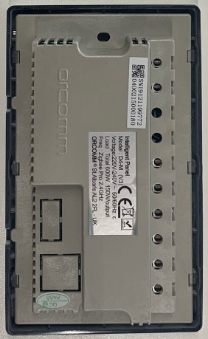

D1M = Dimmer 1 gang Master

D4M = Dimmer 4 gang Master

V3 = DIGI3 Trailing

+

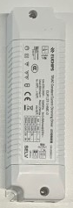

Part No.

EUP12T-1HMCO

+

**DB8 8W (200mA) DB13** **13W (300mA)**

(DIP switch 1 2 OFF) (DIP switch 2 ON)

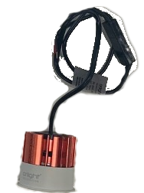 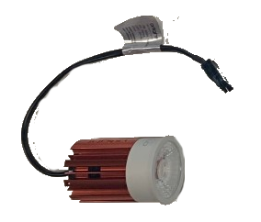

## Leading Edge

**MUST BE INSTALLED WITH DIGI2 ONLY (V2)**

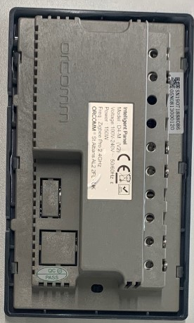

D1M = Dimmer 1 gang Master

D4M = Dimmer 4 gang Master

V2 = DIGI2 Leading

+

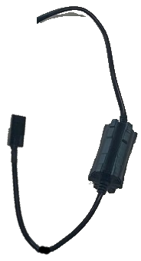

Part No.

DIABLO-MINI-DR-DIM-2IC

+

**DB8 8W (200mA)**



# MVHR boost

The MVHR boost switch (installed inside trunking next to MVHR unit) operates the MVHR when required.

The current setup allows the Kitchen boost switch, and all bathrooms to activate the MVHR switch.

This is achieved by Multimaster function. When programmed the first gang on the switch can be paired to multiple switches. The unit will then recognise when the bathroom or kitchen boost switch is on and give 230V to the MVHR unit. When all are turned off then the MVHR switch will remove the 230V.

***Q: Why is the switch hidden in the trunking behind blank plate.***

*A: Instruction on site was to hide the unit to stop home owners operating accidently.*

***Q: Why do you need to pair the bathroom and kitchen boost switch to the MVHR boost switch?***

*A: There are no wires thus requires wireless signal to operate.*

***Q: How many switches can be programmed to MVHR Multimaster?***

*A: 7*

### MVHR Location

DIGI3-WHI-2-SD (MVHR)

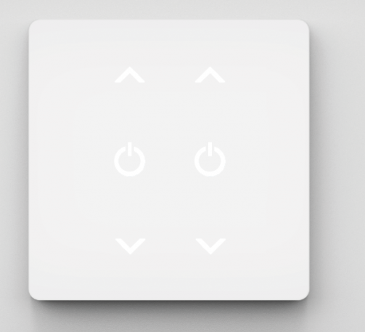

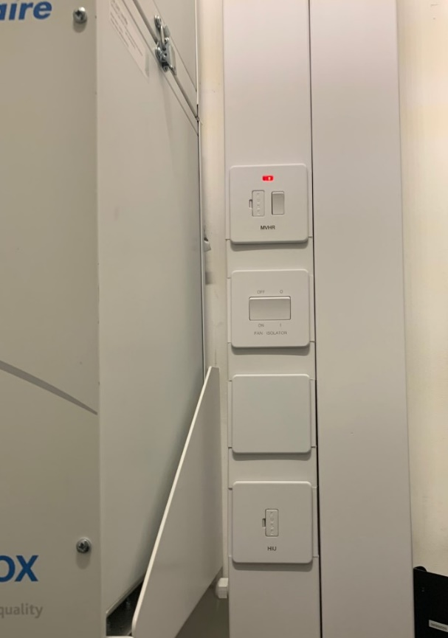 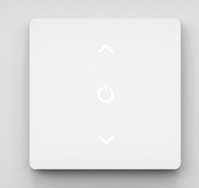 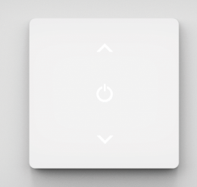

240V power

/ Return





Kitchen boost

Bathroom

# HEATING CONTROL .

# Room Thermostat

ORC-HC2-24D-RS485-WHF (Dual reading thermostat – Local and Floor)

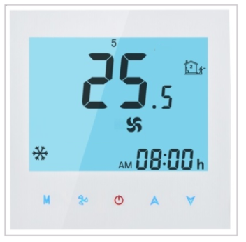 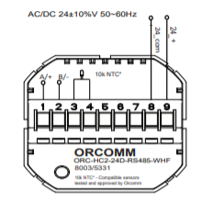

## Programming options

Turn OFF

Press and hold M followed by Fan icon then let go when screen changes

NOTE: you know press M to go through the below options. There is 5 seconds before time out.

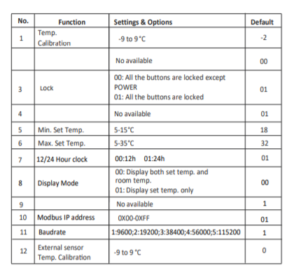

***Q: Can you read the temperature from the floor sensor wired into the rear***

*A: NO – this is an override sensor (ie. 30 degrees)*

***Q: Where do you change the override temperature***

*A: in the HAGW*

# HAGW programmer

## Connecting

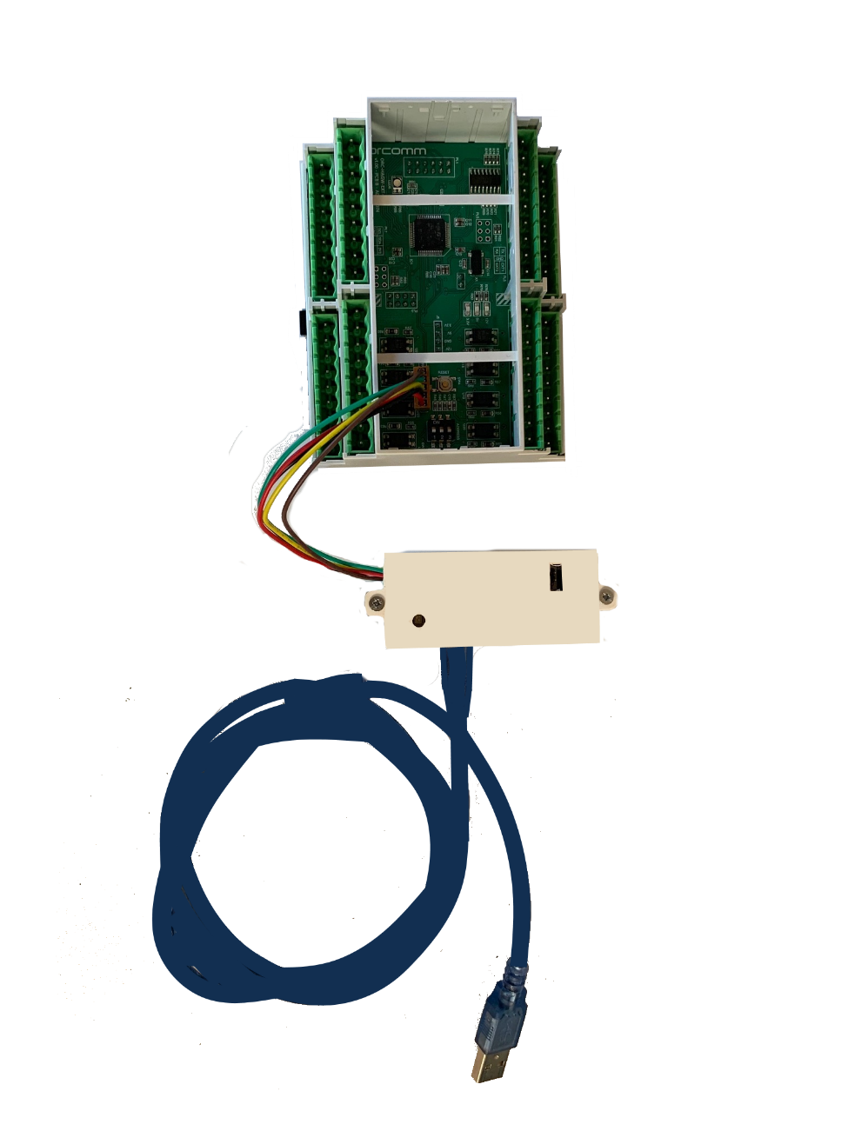

ORC-HAGW

ORC-HAGW-2

Mini USB Lead

ORC-HAGW-PR

ORC-HAGW-EXT-B

ORC-HAGW-EXT-C

The RED power wire connects to the square input

# HAGW software

Within each apartment there is a set configuration for Fan speed, low, medium and high.

To change these settings or to swap a faulty unit you will require

* ORC-HAGW-PROGRAMMER
* LAPTOP with windows 7 minimum and USB port
* Access to internet to compile the program. Note once file is on PC internet will not be needed.

## Website

### os.mbed.com

Last known credentials

Username: [orcomm@snailmail.me.uk](mailto:orcomm@snailmail.me.uk)

Password: lumakingscross

## Home Page

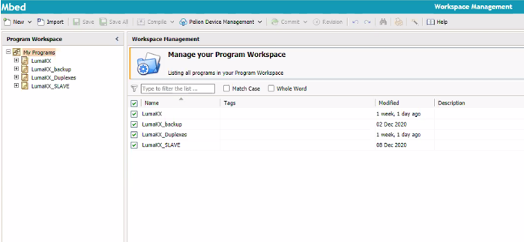

## Files

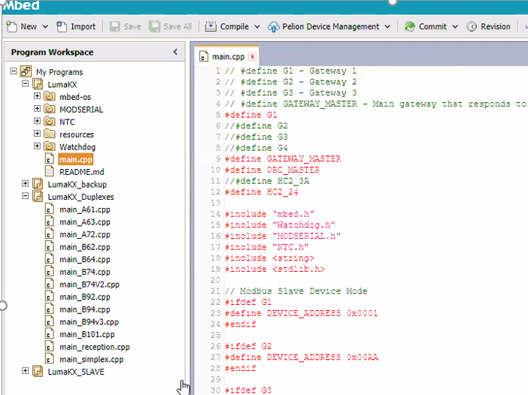

Library examples Files to copy text and paste in above main.cpp

Main file to paste / amend

# Compiling File for HAGW

## Setting for Gateway 1

## Setting for Gateway 2

## 

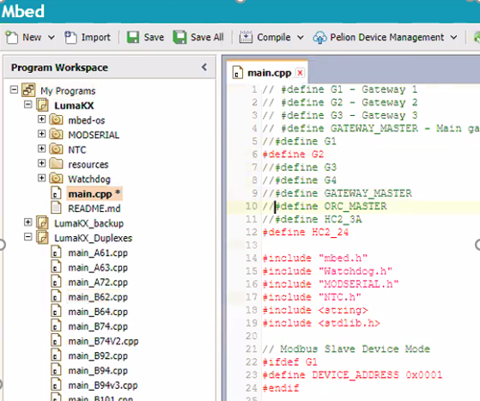

## Setting for Gateway 3

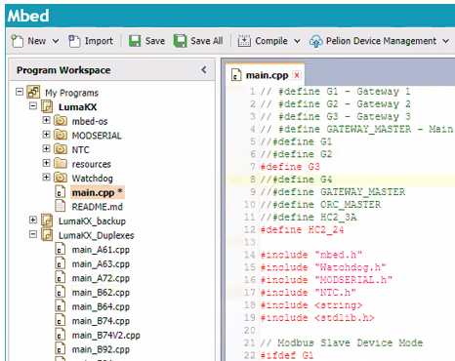

# Adjusting Fan Max

# Adjusting Fan speed medium and high

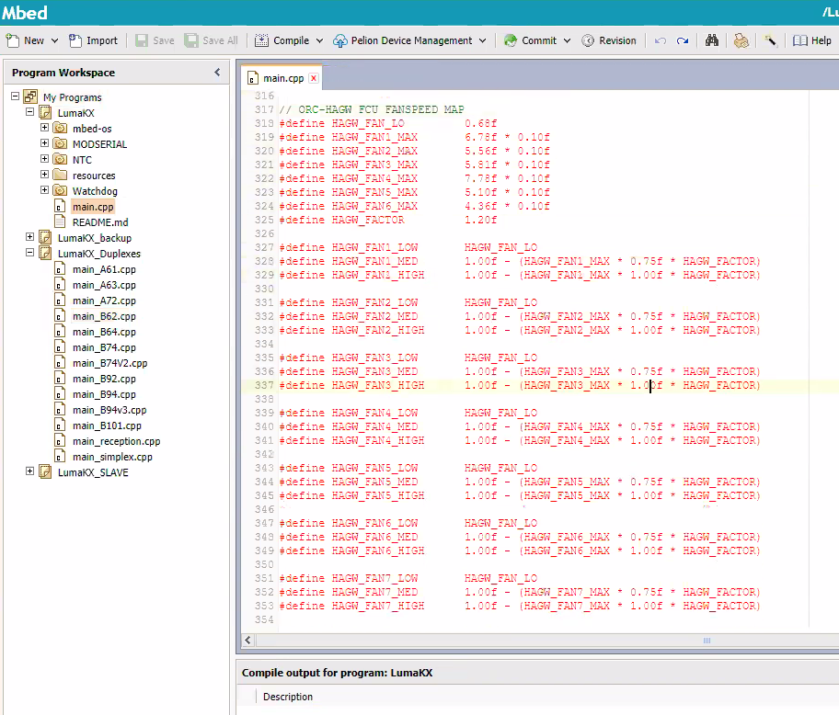

0.75f (default – approx. 75%) - to reduce enter lower value i.e. 0.50f

1.00 (default – approx. 100%)

## Relay / Actuator reference to Zone

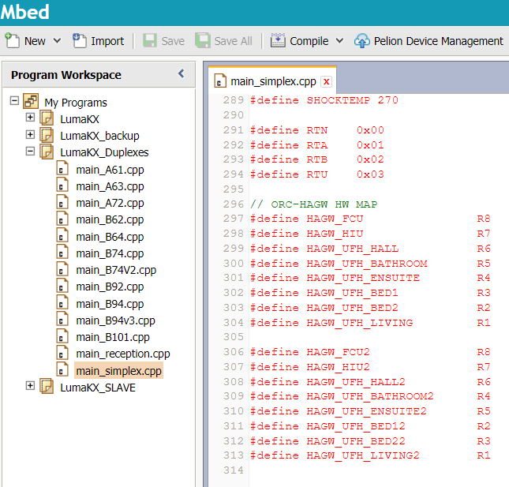

This can be found inside the apartment or via Excel Spreadsheet in Luma files.

## Make the file for the HAGW

Click on the icon in the banner



The system will then compile and take approx. 20-45 seconds

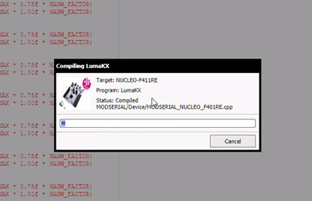

Save the file locally to your pc (only use standard letters and numbers with in the name)

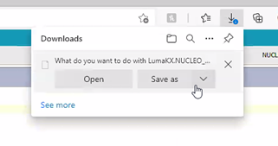

**Technical FAQ**

**Q = Question A = Answer M = More information**

**Q: Do we need orcomm to program the DIGI2 range of light switch.**

A: Yes or orcomm Gold partner. They will use software MPLAB-IDE V4.1 software and Files from Partner server

M: the reason you may need the orcomm / partner is the factory default is set with a large range for dimming. With no min and max set the customer might hold the button on UP and not see any changes (as the max had already been reached)

NOTE NET zigbee from screen followed by pairing to screen and any secondary (intermediate) switches.

**Q: Do we need orcomm to program the DIGI3 range of light switch.**

A: NO, these light switches can be set to Trailing edge by pressing buttons on unit as well as setting MIN/MAX levels

M: When programming the light switch you will need to set Trailing edge, Min and Max on each circuit. Then NET zigbee from screen followed by pairing to screen and any secondary (intermediate) switches.

**Q: Do we need to change Linear drivers (ie. Strip drivers)**

A: From our purchasing records you will not need to change these drivers as they are dual technology and work on Leading or trailing edge. Please note we are not familiar with the site and these may have additional drivers not on our records.

M: Drivers used for linear are normally large and have room for dual technology components. Hence why most work well.

**Q: Can we Mix and match DB8 / DB13 on same circuit**

A: We have never tested this solution, contact Orlight and ask for performance test with mixed engine drivers.

M: Although on paper this might seem to be correct, we must take into consideration light levels etc.

**Q: Why is the MVHR not working when I turn on bathroom lights**

A: 1st is the MVHR unit powered, 2nd is the MVHR boost switch on and can this operate the MVHR. Note this is a 2 gang switch hidden next to MVHR inside trunking behind metal blanking plate. 3rd do any bathroom switches or kitchen boost operate the MVHR, if no then this is more likely to be pairing issue to MVHR boost switch. IF some operate but not all then repair the switches that do not work with MVHR boost switch

# Links

Website: [www.orcomm.co.uk](http://www.orcomm.co.uk)

Videos: <http://downloads.orcomm.co.uk/#Downloads%2FVideos>

Manuals: <http://downloads.orcomm.co.uk/#Downloads%2FManuals>

Orcomm Connect for phone: [www.orcommconnect.co.uk](http://www.orcommconnect.co.uk)

Sharepoint Folder: <https://orcommltd-my.sharepoint.com/:f:/g/personal/info_orcomm_co_uk/EnZ5DIfW8LFHliplv-SQBc0BAOD7dC8emytSXil8JkqOUQ?e=f9XGqz>